1_Configure IP SLA tracking and path control topology.

Aim: Configure IP SLA tracking and path control topology.

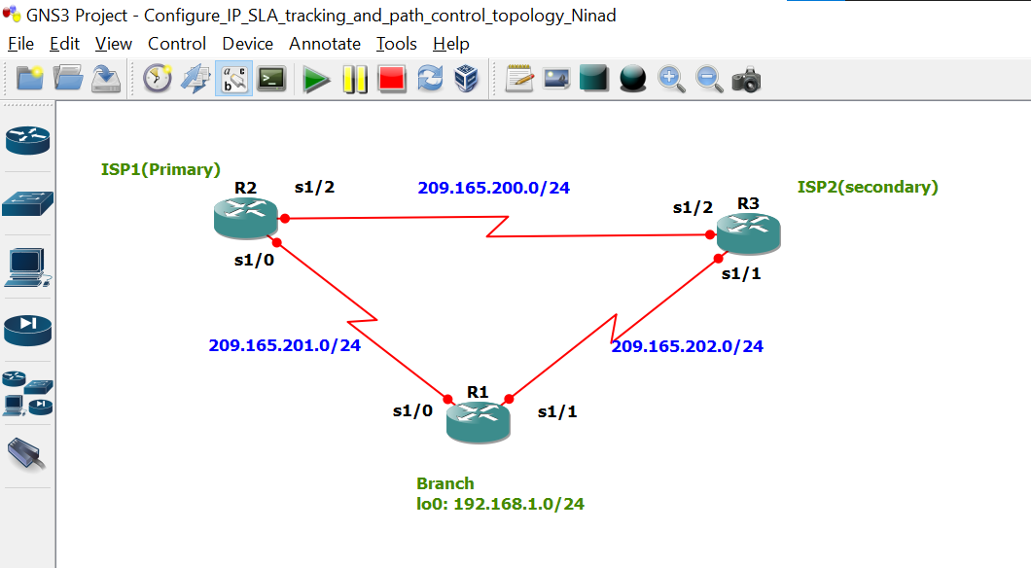
Take 3 routers -> Configure -> slots -> NM-4T
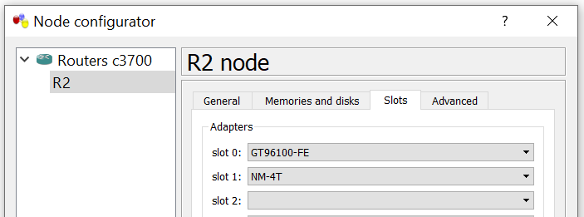

Task 1: Configure IP SLA using GNS3
On router 1 console
R1 #
R1 # conf t
R1(config) # int s1/0
R1(config-if) # ip add 209.165.201.1 255.255.255.0
R1(config-if) # no sh
R1(config-if) #
R1(config-if) # int s1/1
R1(config-if) # ip add 209.165.202.1 255.255.255.0
R1(config-if) # no sh
R1(config-if) #
R1(config-if) # int lo0
R1(config-if) # ip add 192.168.1.1 255.255.255.0
R1(config-if) #
R1(config-if) # do sh ip int br | include up
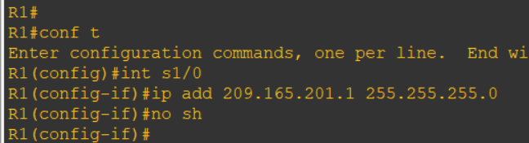
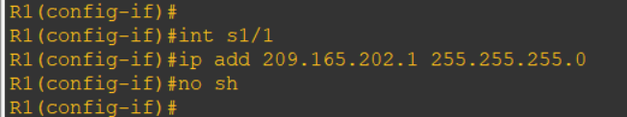
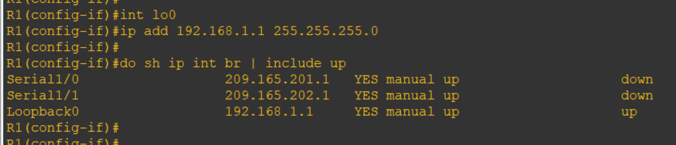
On router 2 console
R2 # conf t
R2(config) # int s1/0
R2(config-if) # ip add 209.165.201.2 255.255.255.0
R2(config-if) # no sh
R2(config-if) #
R2(config-if) # int s1/2
R2(config-if) # ip add 209.165.200.2 255.255.255.0
R2(config-if) # no sh
R2(config-if) #
R2(config-if) # do sh ip int br | include up
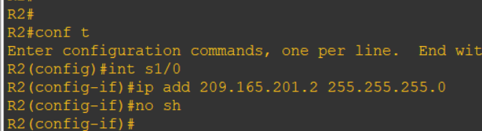
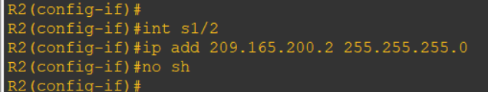
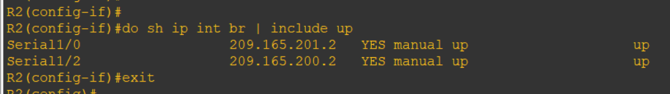

On router 3 console
R3 # conf t
R3(config) # int s1/1
R3(config-if) # ip add 209.165.202.3 255.255.255.0
R3(config-if) # no sh
R3(config-if) #
R3(config-if) # int s1/2
R3(config-if) # ip add 209.165.200.3 255.255.255.0
R3(config-if) # no sh
R3(config-if) #
R3(config-if) # do sh ip int br | include up
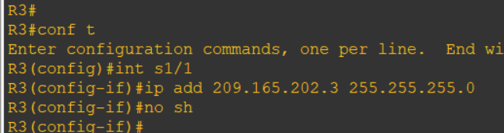
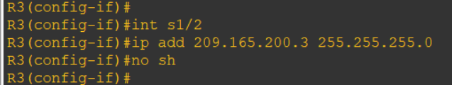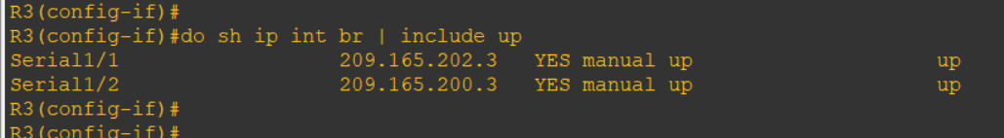

Task 2: Configure static routing on branch router and dynamic routing using eigrp
On router 1 console
R1 # conf t
R1(config) # ip route 0.0.0.0 0.0.0.0 209.165.201.2
R1(config) #

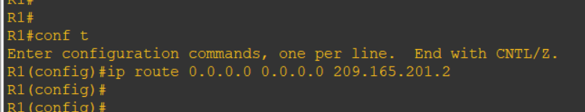

On router 2 console
R2(config) # router eigrp 1
R2(config-router) # network 209.165.200.0 0.0.0.255
R2(config-router) # network 209.165.201.0 0.0.0.255
R2(config-router) # no auto-summary
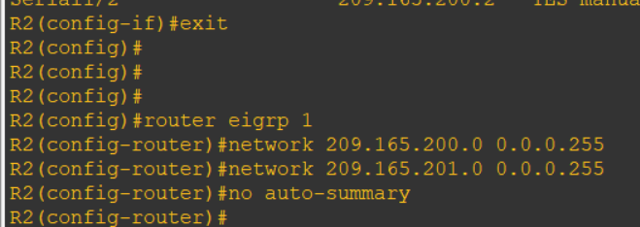

On router 3 console
R3(config) # router eigrp 1
R3(config-router) # network 209.165.200.0 0.0.0.255
R3(config-router) # network 209.165.202.0 0.0.0.255
R3(config-router) # no auto-summary
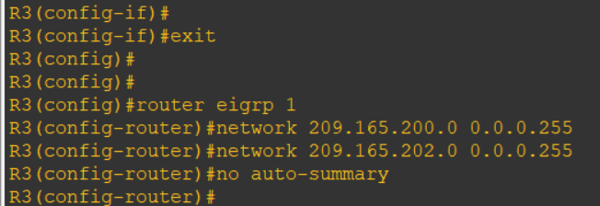

On router 2 console
R2(config-router) # exit
R2(config) # ip route 192.168.1.0 255.255.255.0 209.165.201.1
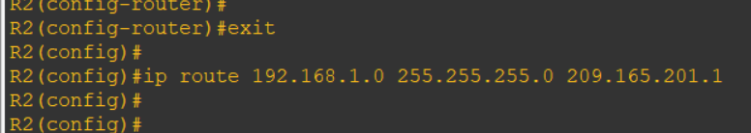

On router 3 console
R3(config-router) # exit
R3(config) # ip route 192.168.1.0 255.255.255.0 209.165.202.1
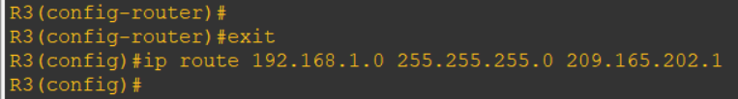

Ping other routers
R1(config) # do ping 209.165.200.3
R3(config) # do ping 209.165.201.1
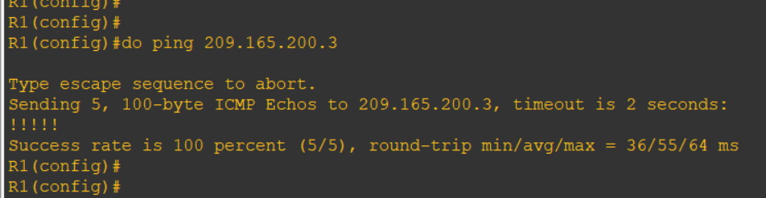
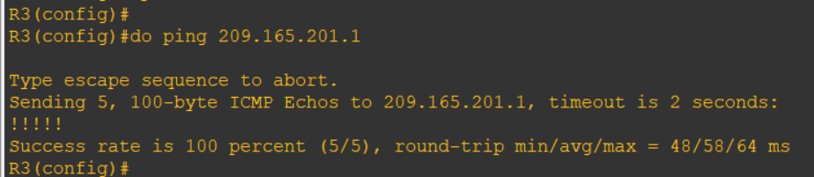

Ping other routers
R2(config) # do ping 192.168.1.1
R3(config) # do ping 192.168.1.1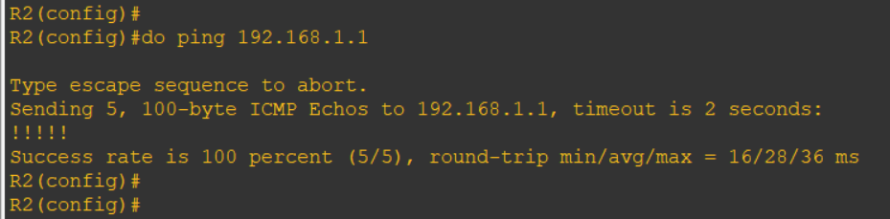
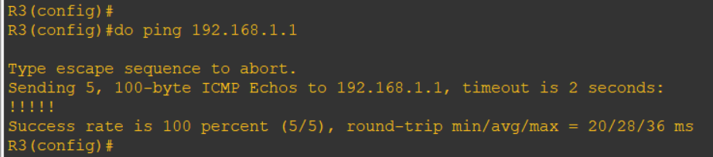

Give hostname
R1(config) # hostname r1-branch
R2(config) # hostname r2-isp1
R3(config) # hostname r3-isp2

Task 3: Configure IP SLA probes at branch router
On router 1 console
r1-branch(config) # ip sla 11
r1-branch(config-ip-sla) # icmp-echo 209.165.201.2
r1-branch(config-ip-sla-echo) # frequency 10
r1-branch(config-ip-sla-echo) # exit
r1-branch(config) #
r1-branch(config) # ip sla schedule 11 life forever start-time now
r1-branch(config) #
r1-branch(config) # do sh ip sla configuration 11
